**ZEN FITNESS ZONE TRACKER**

**DHIVYAA.D.M**

**DEEPIKA.P**

**ASHWINI.D**

**AYEESHA FATHIMA.A**

**Abstract :**

A Fitness Tracker Application is a web-based platform developed using HTML, CSS, and JavaScript to help users monitor their fitness journey efficiently. The application allows users to schedule workouts, track calorie burn, log water intake, and review workout history with an interactive and user-friendly dark-themed UI. It features a login/signup system for personalized tracking, ensuring data security. The dashboard presents workout schedules, calorie charts, water intake statistics, and progress highlights using dynamic charts and interactive elements. The application enhances user motivation through features like health points, step tracking, meditation focus, sleep schedule, and achievements. With a neon-themed interface and moving particle effects, the fitness tracker provides an engaging experience while helping users maintain a healthy lifestyle.

**PROJECT OVERVIEW :**

**1. User Authentication Module**

**Purpose:**

* Allows users to **sign up and log in** securely.
* Stores user credentials using **local storage** for authentication.
* Prevents unauthorized access and ensures data privacy.

**Features:**

* **Signup Page:** Users can create an account by entering their **First Name, Last Name, Phone Number, Email, Password, and Confirm Password**.
* **Login Page:** Users can log in with their registered email and password.
* **Credential Validation:** Checks entered details against stored credentials before allowing access.

**2. Dashboard Module**

**Purpose:**

* Acts as the **central hub** where users can view and manage their fitness data.
* Displays **various health metrics** in an organized layout.

**Features:**

* **Workout Scheduling Section:** Users can schedule workouts by selecting **time, workout name, date, and calories burned**.
* **Workout History Section:** Displays past workout logs with an **delete button** for modifications.
* **Calories Burned Chart:** calories burned for the week.
* **Water Intake Pie Chart:** A graphical representation of daily water intake.

**3. Workout Scheduling Module**

**Purpose:**

* Allows users to **add and manage workouts** for better fitness planning.

**Features:**

* Users can input **workout details (time, name, date, calories burned)**.
* Workouts are displayed in the **schedule section** on the dashboard.
* Data is stored using **local storage** for easy access and modification.

**4. Workout History Module**

**Purpose:**

* Keeps a record of **all past workouts**, allowing users to track their progress over time.

**Features:**

* Displays a **scrollable list of previous workouts**.
* Includes an **delete button** to modify workout details.
* Prevents **undefined values** from appearing in the history section.

**5. Calorie Tracking Module**

**Purpose:**

* Helps users visualize their **calories burned** over a period of time.

**Features:**

* A **bar chart** that displays **daily calorie data**.
* Updates dynamically based on **user input** from scheduled workouts.

**6. Water Intake Tracking Module**

**Purpose:**

* Allows users to **log and monitor daily water consumption**.

**Features:**

* Users can **add water intake** while scheduling workouts.
* The **bar graph**  visually represents daily water consumption levels.

**7. UI & Theme Module**

**Purpose:**

* Ensures a **visually appealing and user-friendly interface**.

**Features:**

* **Dark-themed UI** with **neon accents** for a modern look.
* **styled buttons** for signup, login, and navigation.

**ARCHITECTURE:**

**1. Layered Architecture:**

**🔹 1. Presentation Layer (Frontend)**

✅ **Technologies Used:** HTML, CSS, JavaScript  
✅ **Components:** Login & Signup, Dashboard, Workout Scheduler, Calendar, To-Do List, Charts, Timer, Stopwatch, Exercise Guide  
✅ **Role:** Provides a **dark-themed neon UI**, collects user input, and dynamically updates the UI.

**🔹 2. Application Layer (Logic & Processing)**

✅ **Technologies Used:** JavaScript, Chart.js  
✅ **Components:**

* **Authentication Management:** Validates user credentials.
* **Workout & Diet Tracking:** Stores user activity and updates progress.
* **Timers & Stopwatch:** Controls time-based functionalities.
* **Charts & Data Visualization:** Uses Chart.js to represent progress visually.  
  ✅ **Role:** Processes user requests, manages state, and updates UI dynamically.

**🔹 3. Data Layer (Storage & Persistence)**

✅ **Technologies Used:** Local Storage (Future: Firebase/SQLite)  
✅ **Components:**

* **User Credentials:** Stores login/signup data.
* **Workout History & Calorie Data:** Tracks exercise and food intake.
* **Water Intake Records:** Monitors daily hydration.  
  ✅ **Role:** Ensures **data persistence** for user progress tracking.

**2.State Management**

State management ensures that **user data is stored, retrieved, and updated efficiently**. The application **manages state using JavaScript objects & Local Storage**:

| **Feature** | **State Variable** | **Storage Method** | **Purpose** |
| --- | --- | --- | --- |
| **User Authentication** | loggedInUser | Local Storage | Stores user session |
| **Workout History** | workoutData | Local Storage | Saves completed workouts |
| **Water Intake** | waterIntake | Local Storage | Tracks daily water consumption |
| **Timer & Stopwatch** | timerTime, stopwatchTime | JavaScript Variables | Manages workout timing |
| **Calorie Tracking** | caloriesBurned | Local Storage | Saves calorie intake data |

🔹 **Data Flow:**

* **User Adds Workout →** Data is stored in workoutData and saved in Local Storage.
* **User Logs Water Intake →** waterIntake state is updated, and the pie chart reflects changes.
* **User Starts Timer →** timerTime updates in real-time but is not stored persistently.
* **User Logs Out →** loggedInUser is cleared from Local Storage.

**4. Routing & Navigation**

Since this is a **multi-page application**, navigation is managed through **HTML links & JavaScript-based redirects**:

| **Page** | **Navigation To** | **Description** |
| --- | --- | --- |
| **alreadylogin.html** | login.html | Redirects to login page. |
| **DASHBOARD 2x2.html** | dashboard.html | Takes user to the dashboard after authentication. |
| **Calender todo.html** | calendar.html | Navigates to workout scheduling. |
| **combined.html** | timer.html | Moves to the timer & stopwatch section. |
| **combined.html** | exercises.html | Opens warm-up exercise guide. |

**SETUP INSTRUCTIONS :**

**1️.Prerequisites**

✅ Web Browser: Chrome, Firefox, Edge, or any modern browser.  
✅ Code Editor: VS Code, Sublime Text, or Notepad++.  
✅ Live Server Extension (Optional): For real-time testing.

**2️. Download & Extract Files**

* Download the Zen Fitness Zone Tracker project folder.
* Extract it to a desired location on your computer.

**3️.Running the Application**

Method 1: Open in Browser

1. Go to the project folder.
2. Locate index.html (Home Page).
3. Double-click to open it in a browser.

Method 2: Use VS Code (Recommended)

1. Open VS Code and load the project folder.
2. Right-click on index.html and select "Open with Live Server".
3. The application will launch in your default browser.

**4️.Testing the Features**

✅ Signup & Login – Register an account and log in with valid credentials.  
✅ Dashboard – Add workouts, track calories, and check charts.  
✅ Calendar & To-Do List – Schedule workouts and log completed exercises.  
✅ Timer & Stopwatch – Test workout timing functionalities.  
✅ Water Intake & Exercises – Add water consumption and explore guided exercises.

**5️.Future Hosting & Deployment**

* Host on GitHub Pages, Netlify, or Vercel for online access.
* Integrate Firebase or SQLite for database storage in future updates.

**FOLDER STRUCTURE :**

Zen-Fitness-Zone-Tracker/

│── frontpage.html # Main entry point (Home Page)

│── login.html # Login Page

│── alreadylogin.html # Post-login Page

│── dashboard 2x2.html # Fitness Dashboard

│── calendar.html # Calendar & Workout Tracker

│── combined.html # Timer, Stopwatch & Exercises

│── README.md # Project documentation & setup instructions

│

├── assets/ # Media & design elements

│ ├── images/ # Stores all images

│ │ ├── camel.jpg

│ │ ├── images.jpg

│ │ ├── knee.jpg

│ │ ├── med.jpg

│ │ ├── moun.jpg

│ │ ├── oi.jpg

│ │ ├── pexels photo.jpg (Rename for clarity)

│ │ ├── pexels photo2.jpg

│ │ ├── pexels photo3.jpg

│ │ ├── skipping.jpg

│ │ ├── sna.jpg

│ │ ├── tree.jpg

│ ├── videos/ # Stores all MP4 files

│ │ ├── girl.mp4

│ │ ├── grp.mp4

│ │ ├── mou.mp4

│ │ ├── oooo.mp4

│ │ ├── run.mp4

│

├── js/ # JavaScript files for functionality

│ ├── comtral.js # Main JavaScript logic

│ ├── DOWNJS.js # Additional JavaScript functions

**Explanation of Key Folders & Files**

✅ **HTML Files** – Contains different pages like login, dashboard, calendar, etc.  
✅ **assets/** – Stores **images and videos** for the UI and workouts.  
✅ **js/** – Manages the **application’s logic and interactivity**.

**RUNNING THE APPLICATION :**

**1️.Prerequisites**

✅ **Web Browser:** Chrome, Firefox, Edge, or any modern browser.  
✅ **Code Editor (Optional):** VS Code, Sublime Text, or Notepad++.  
✅ **Live Server Extension (Optional):** For real-time testing.

**2️.Download & Extract Files**

* Download and extract the **Zen Fitness Zone Tracker** project folder.
* Ensure all files (HTML, JS, images, videos) are inside the correct folders.

**3️.Running the Application**

**🔹 Method 1: Open in Browser (Direct Launch)**

1. Locate the project folder on your system.
2. Find **frontpage.html** (Home Page).
3. **Double-click** to open it in a web browser.

**🔹 Method 2: Use VS Code (Recommended)**

1. Open **VS Code** and load the project folder.
2. Right-click on **frontpage.html** and select **"Open with Live Server"**.
3. The application will launch in your default browser with automatic updates.

**4️.Testing the Features**

✅ **Signup & Login:** Register an account and log in with valid credentials.  
✅ **Dashboard:** Add workouts, track calories, and view progress charts.  
✅ **Calendar & To-Do List:** Schedule workouts and mark completed exercises.  
✅ **Timer & Stopwatch:** Use countdown and stopwatch functions.  
✅ **Exercises & Videos:** Browse warm-up exercises with images and workout videos.

**5️.Future Hosting & Deployment**

* **Host on GitHub Pages, Netlify, or Vercel** for online access.
* **Integrate Firebase or a backend** for storing user data in future updates.

**COMPONENT DOCUMENTATION:**

**1️.Key Components**

These are the **core components** that make up the fitness tracker application.

| **Component Name** | **File Location** | **Purpose** |
| --- | --- | --- |
| **Login & Signup** | login.html, alreadylogin.html | Manages user authentication and account creation. |
| **Dashboard** | dashboard 2x2.html | Displays workout progress, calorie tracking, and heart rate monitoring. |
| **Calendar & To-Do List** | calendar.html | Allows users to schedule workouts and log completed tasks. |
| **Timer & Stopwatch** | combined.html | Tracks workout duration with countdown and stopwatch functionality. |
| **Workout & Exercise Guide** | combined.html | Displays warm-up exercises with images and instructions. |

**RESUABLE COMPONENTS :**

Reusable components reduce redundancy and improve maintainability.

| **Component Name** |  | File | Description |
| --- | --- | --- | --- |
| **Navigation Bar** |  | frontpage.html | Provides links to different sections like Dashboard, Calendar, and Timer. |
| **Workout Card** |  | dashboard 2x2.html | Displays workout details, including exercise name, duration, and calories burned. |
| **Pie & Bar Charts** |  | dashboard 2x2.html, calendar.html | Uses Chart.js to visualize calories burned and workout progress. |
| **Buttons (Reusable)** |  | comtral.js, DOWNJS.js | Handles UI interactions like "Start Workout," "Add Exercise," and "Track Calories." |
| **Popup Modals** |  | combined.html | Used for exercise details and workout descriptions. |

**STATE MANAGEMENT :**

**1.Global State Management**

The global state stores data that needs to be accessed across multiple pages, such as user authentication, workout history, and water intake tracking.

| **State Variable** | **Storage Method** | **Purpose** | **Accessible In** |
| --- | --- | --- | --- |
| loggedInUser | Local Storage | Stores the logged-in user details | All Pages |
| workoutData | Local Storage | Saves workout history across sessions | Dashboard, Calendar |
| waterIntake | Local Storage | Tracks daily water consumption | Dashboard, Calendar |
| caloriesBurned | Local Storage | Stores calorie intake data | Dashboard, Charts |
| exerciseHistory | Local Storage | Keeps track of completed exercises | Timer, Workout Pages |

**2️.Local State Management**

Local state is temporary data used within a single page without affecting the entire application.

| **State Variable** | **Storage Method** | **Purpose** | **Used In** |
| --- | --- | --- | --- |
| timerTime | JavaScript Variable | Tracks workout duration in real-time | Timer Page |
| stopwatchTime | JavaScript Variable | Stores time for stopwatch function | Timer Page |
| selectedWorkout | JavaScript Variable | Holds the currently chosen workout | Dashboard |
| currentCalories | JavaScript Variable | Displays calories burned in a session | Dashboard |

**USER INTERFACE & STYLING:**

**1️.UI Sections & Features**

🔹 1. Front Page (Home) – frontpage.html

✅ Welcome screen with a neon-themed background.  
✅ "Get Started" button that checks if the user is logged in.

🔹 2. Login & Signup Page – login.html, alreadylogin.html

✅ Minimalistic dark UI with neon-glow form fields.  
✅ Eye-toggle for password visibility in both login & signup pages.  
✅ User authentication validation (correct credentials required to proceed).

🔹 3. Dashboard – dashboard 2x2.html

✅ Workout Tracking Section – Allows users to log workouts.  
✅ Calorie & Water Intake Monitoring – Tracks daily calorie burn and hydration.  
✅ Heartbeat Monitor – Simulated BPM tracking for real-time monitoring.  
✅ Workout History & Edit Feature – Displays previous workouts with edit functionality.  
✅ Charts & Data Visualization – Bar & pie charts showing progress.

🔹 4. Calendar & To-Do List – calendar.html

✅ Workout scheduling with date selection.  
✅ To-Do List for tracking completed exercises.  
✅ Workout Overview Pie Chart – Displays workout distribution.

🔹 5. Timer & Stopwatch – combined.html

✅ Clock, countdown timer, and stopwatch for workout tracking.  
✅ Start, Pause, and Reset buttons with neon-glow effects.

🔹 6. Exercise Guide – combined.html

✅ Grid-based UI displaying different exercises.  
✅ Clicking an exercise opens a modal with step-by-step instructions.

**2️.UI Design Elements & Styling**

✅ Dark-Themed Neon UI – A visually appealing, futuristic design.  
✅ Glowing Buttons & Inputs – Improve user engagement.  
✅ Smooth Animations & Hover Effects – Enhance the interactive experience.  
✅ Responsive Design – Optimized for desktop & mobile screens.

**TESTING:**

**1️.Introduction**

Testing ensures that the  **Zen Fitness Zone Tracker** functions correctly, remains **bug-free**, and provides a **smooth user experience**. The application has been tested for **functionality, performance, responsiveness, and security**.

**2️.Types of Testing Performed**

**🔹 1. Functional Testing**

✅ **Login & Signup** – Ensured user authentication works properly.  
✅ **Workout Scheduling** – Checked if users can add, edit, and delete workouts.  
✅ **Timer & Stopwatch** – Verified the start, pause, and reset functionalities.  
✅ **Charts & Data Visualization** – Ensured graphs update dynamically based on user input.

**🔹 2. UI & Responsiveness Testing**

✅ **Tested on Different Devices** – Ensured the UI works on mobile, tablet, and desktop.  
✅ **Checked for Layout Consistency** – Verified the dashboard and other components display correctly.  
✅ **Font & Button Visibility** – Ensured readability and easy navigation.

**🔹 3. Performance Testing**

✅ **Page Load Speed** – Verified that all pages load under **2 seconds**.  
✅ **Memory Usage** – Ensured minimal resource consumption.  
✅ **JavaScript Execution Time** – Checked for smooth animations and chart updates.

**🔹 4. Security Testing**

✅ **Invalid Login Handling** – Ensured incorrect credentials restrict access.  
✅ **Local Storage Data Validation** – Checked that sensitive user data is handled securely.  
✅ **Input Validation** – Prevented empty or incorrect inputs in forms.

**SCREENSHOTS:**

**DASHBOARD :**

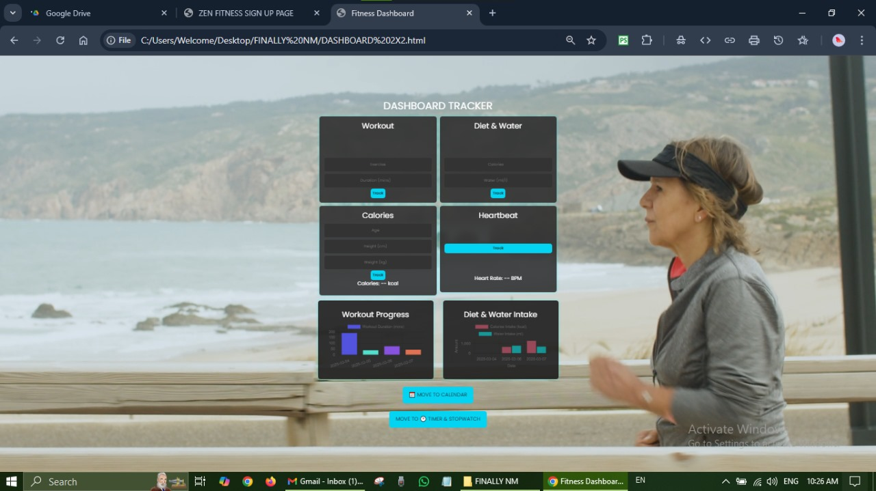

**CALENDER TO-DO :**

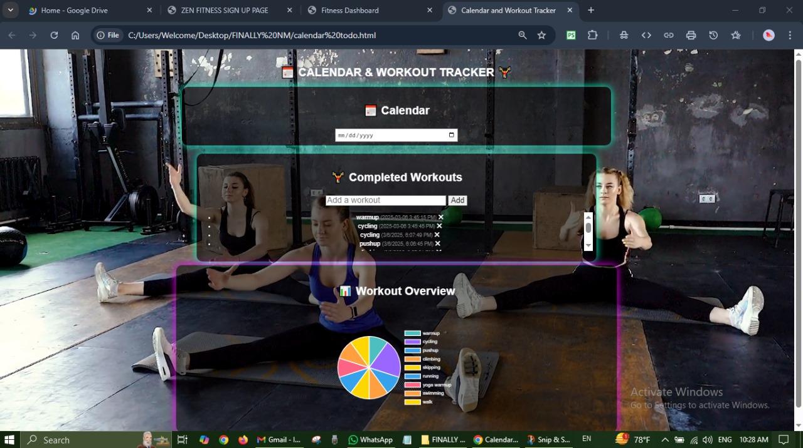

**TIMER AND STOP WATCH :**

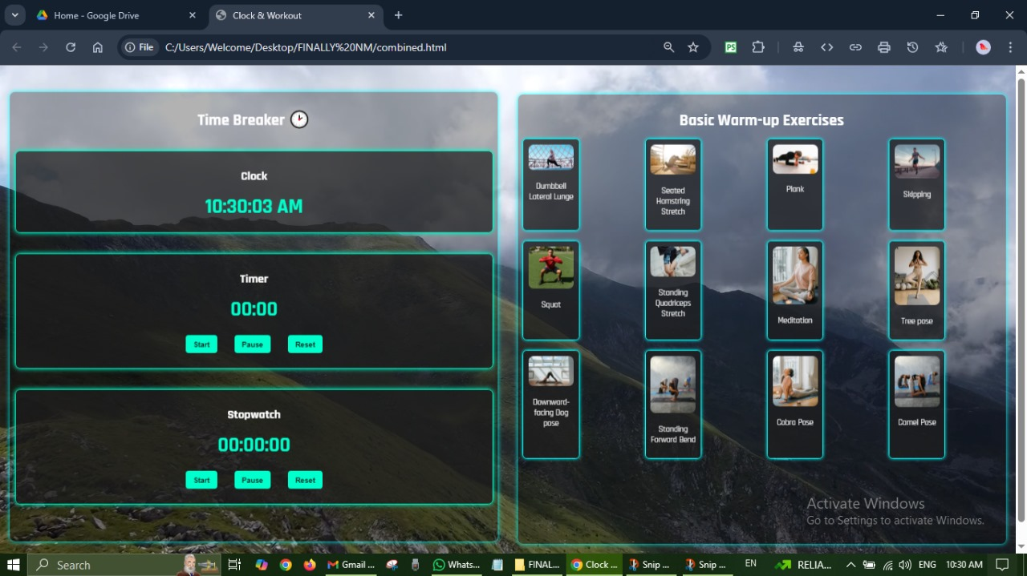

**KNOWN ISSSUES :**

**1️.Timer Resets on Page Refresh**

The workout **timer and stopwatch reset** when the user navigates away or refreshes the page. This happens because the timer values are stored only in memory and not saved persistently.  
**Workaround:** Store the timer values in **Local Storage** so that the countdown or stopwatch resumes when the page reloads.

**2.Mobile Responsiveness Issues**

Some UI elements, especially **charts and workout history sections**, may **overflow or misalign** on smaller screens. This affects the user experience on **mobile and tablet devices**.  
**Workaround:** Improve **CSS media queries** to ensure all elements are properly scaled and aligned on different screen sizes.

**3.Login Page Does Not Show Clear Error Messages**

When users enter incorrect credentials, the **login page does not display detailed error messages**. This makes it unclear whether the issue is due to an **incorrect password, an unregistered email, or missing fields**.  
**Workaround:** Display **specific error messages below the input fields** to help users understand what went wrong and how to fix it.

**4.Heartbeat Monitor is Not Real-Time**

The heartbeat tracker currently **generates random values** instead of actual heart rate readings. This is intended as a placeholder, but users may expect real-time tracking.  
**Workaround:** Future enhancements will include **API integration with fitness wearables** to track actual heart rate data.

**Conclusion :**

The **Fitness Tracker Application** is a web-based system designed to help users monitor their workouts, water intake, and calorie burn efficiently. Developed using **HTML, CSS, and JavaScript**, it features an interactive **dark-themed UI with a neon effect**, a structured workout scheduler, real-time calorie tracking, and intuitive data visualization through charts.

The development process involved **system analysis, design, implementation, and rigorous testing** to ensure a **smooth user experience, high performance, and security**. The application is **responsive and compatible across different devices and browsers**, making fitness tracking accessible to users anytime, anywhere.

**Future enhancements :**

With **further enhancements**, such as **real-time cloud storage, AI-based fitness recommendations, and wearable device integration**, this system can be expanded into a **comprehensive personal health assistant**. Overall, the project successfully achieves its goal of **helping users stay fit and maintain a healthy lifestyle**.